AI-Based Internship Recommendation Engine for PM Internship Scheme

Anusha M S
ANUSHA.20221ISE0171@presidencyuniversity.in
Dept. of Computer Science and Engineering
Bio-intelligence lab,
Presidency University, Bengaluru, India

Kumar G K
Kumargk.2023ISE3001@presidencyuniversity.in
Dept. of Computer Science and Engineering
Bio-intelligence lab,
Presidency University, Bengaluru, India

Sindhu L Y
SINDHU.20221ISE0162@presidencyuniversity.in
Dept. of Computer Science and Engineering
Bio-intelligence lab,
Presidency University, Bengaluru, India.

Dr. Prajeesh C B
Assistant Professor
Dept. of Computer Science and Engineering
prajeesh@presidencyuniversity.in
Presidency University, Bengaluru, India

Abstract - The recent surge in the adoption of artificial intelligence recruitment platforms has generated a high demand for accurate and intelligent internship recommendation systems that can interpret deep semantic relationships between resumes and internship descriptions. The existing keyword-based and rule-based recommendation systems often generate irrelevant and incomplete recommendations due to the lack of contextual understanding, skill relationships, and domain knowledge represented in the text data. In this work, an AI Internship Recommendation System is proposed that leverages automated resume parsing, skill details extraction, TF-IDF, BERT, and Sentence Transformers semantic embeddings for accurate internship recommendations. The proposed hybrid semantic embedding model is compared with the traditional keyword-based matching approach
using accuracy, precision, and response time. The results confirm the efficacy of the proposed approach with a relative improvement of about 15% in recommendation accuracy and a substantial reduction in response time, thus proving the efficacy of contextual semantic embedding models for scalable academic placement and recruitment assistance systems. The proposed approach is implemented using Python NLP pipelines.

Keywords-- Internship Recommendation, Semantic Matching, Resume Processing, BERT, Sentence Transformers, Artificial Intelligence, Recruitment Analytics.

Introduction

Internships provide a critical bridge between the classroom and the real-world industry experience. Internships enable students to gain direct technical exposure and improve their employability. With the sudden increase in the number of internship opportunities available in the fields of artificial intelligence, data science, and software development, it becomes challenging for students to identify internships that match their skill sets and interests. Searching for internships manually through job portals is a time-consuming process and often leads to inappropriate applications, lower chances of selection, and ineffective recruitment.

The conventional recommendation systems for internships rely largely on keyword filtering, Boolean searches, or rule-based matching. Although these approaches are computationally inexpensive, they do not take into account the contextual semantics, synonyms, or semantic similarities between the content of the resumes and the job descriptions. Thus, possible opportunities might be overlooked if there is no exact keyword match. Recent breakthroughs in natural language processing (NLP) and deep learning, particularly in the transformer models of language, have enabled the capture of contextual semantics in text, which offers a promising approach to the development of intelligent recommendation systems. In this research, a semantic internship recommendation system based on AI is proposed, which integrates resume preprocessing, automatic skill extraction, multi-model embeddings, and similarity ranking. The major contribution of this research is the integration of classical statistical representation (TF-IDF) and deep contextual representation (BERT and Sentence Transformers) for better relevance, accuracy, and real-time feasibility. In addition, this research also contributes to the mathematical modeling of the proposed system.

Literature Review

In the initial resume categorization problems, conventional machine learning algorithms such as Naïve Bayes, decision trees, and support vector machines were employed to categorize candidate resumes into job categories with a reasonable level of accuracy but without any semantic meaning [1]–[3]. Subsequent research efforts included the application of NLP-based preprocessing pipelines that included tasks such as tokenization, stemming, and vector space similarity for better job-resume matching [4], [5].
The emergence of transformer models brought a paradigm shift in the semantic text processing task. BERT demonstrated a high level of contextual understanding of language and brought a significant improvement in semantic similarity and information retrieval tasks over the traditional embedding methods [6], [7]. Deep learning-based resume screening systems further automated the candidate screening task with a lower workload for recruiters while preserving a competitive level of classification accuracy [8].
Later, there were hybrid recommendation models that integrated neural embeddings with information retrieval ranking mechanisms to address the trade-off between computational efficiency and semantic accuracy in recruitment models [9], [10]. Named entity recognition, ontology mapping, and domain taxonomies for skill extraction made it easier to process resumes in a structured manner, resulting in improved recommendations [11], [12].
Context-aware recommendation systems utilized user preferences, behavior, and learning to personalize job recommendations to candidates [13], [14]. Sentence Transformer models proved to be highly effective in semantic similarity evaluation and ranking tasks, making them a great fit for employment recommendation systems [15]. AI-powered career guidance systems that combined various deep learning modules have recently proved scalable for student internship recommendation and counseling assistance [16].
Recent works also investigated graph-based recommendation methods, reinforcement learning optimization, and hybrid semantic-collaborative filtering strategies to improve recruitment intelligence [17]–[20]. Large language model-based reasoning and conversational recommendation systems are also promising future research directions for adaptive career guidance [21]–[25].
However, some limitations still exist in the current state of the art. Most models are partially dependent on keyword overlap, lack unified semantic scoring, or have insufficient experimental evaluation in terms of accuracy metrics. Moreover, response time optimization in real-time recommendation is still an unexplored area. These issues lead to the development of a unified semantic recommendation system that encompasses multi-embedding similarity, ranking optimization, and evaluation, which will be used as a foundation for the proposed system.

III Methodology
The proposed AI Internship Recommendation System uses a structured multi-stage processing pipeline approach that is intended to achieve a high level of semantic understanding, accurate information extraction, and efficient recommendation generation. The architecture of this system is based on the combination of Natural Language Processing techniques, statistical methods for representing text, transformers for creating semantic embeddings, and hybrid ranking algorithms relying on similarity. The system incorporates both contextual language modeling and a skill-oriented approach to increase the accuracy of recommendations and decrease the number of unrelated recommendations. Besides that, this system is highly scalable and offers low latency predictions, which makes it a good fit for usage within universities in terms of internships and placements.
3.1 Data Collection and Resume Acquisition
Data collection includes the collection of resumes from the placement database of the students along with the general internship preparation dataset. The application is compatible with various file formats including PDF, DOCX, and text.
The uploaded files are next processed by means of automated text-parsing systems that can retrieve machine readable text and preserve other components such as headings, bulleted lists, and table data. The following preprocessing steps are applied in order to ensure data quality and consistency: normalization of UTF-8 encoded files, elimination of unwanted formatting elements, and recognition of sentence boundaries.
This is crucial in ensuring that proper textual data is collected in order to perform further Natural Language Processing operations like tokenizing, entity identification, and creating semantic embeddings. This will form a good foundation for performing skill extraction and similarity calculations in the succeeding modules.
3.2 Text Preprocessing and Cleaning

These include tokenization, filtering out of stop words, stripping off of punctuations, lemmatization, and lower casing. The domain specific dictionary of stop words is also used to remove frequently used recruitment terms like responsible, hard-working, and team player since these have no significance for semantic matching.

3.3 Structured Skill and Entity Extraction

The proposed model performs NER and rule-based analysis for extracting structured data from resumes in terms of skills, education, etc., which are then converted into skills through an ontology. Similarly, the process of data preprocessing and feature extraction for internships is performed with experience level and category as additional metadata. For representation purposes, TF-IDF is used to compute the relevance of keywords while cosine similarity and BERT embeddings are calculated to establish relationships between the two data types. The result is a combination of all three similarity metrics in a weighted approach.

3.4 Internship Description Processing
The system uses the Named Entity Recognition (NER) process and rule-based methods to extract structural information about skills and educational backgrounds and other resume attributes, normalized via skill ontology. The internship descriptions are subjected to the same processes as well as more metadata such as level of experience and category. As for the representation, TF-IDF provides weight values for keywords, cosine similarity measures the similarity of descriptions and resumes, and BERT embeddings provide the semantic connection between them. Finally, all values of similarities are combined into a weighted hybrid model, providing a list of relevant internships.
Figure 3.1 Implimentation of the model
3.5 System Implementation
As shown in Figure 3.1 (Implementation of the Model), the process starts from a pipeline approach where the resumes are uploaded, after which text pre-processing takes place using NLP methods. Then comes the part where the important skills and entities are extracted, and then a semantic search is done using the TF-IDF as well as the BERT and Sentence Transformer approach. This is followed by ranking of the internships according to the similarity score.

IV Expermental Results

Several experiments have been carried out to test the effectiveness, semantic validity, and computational complexity of the suggested hybrid internship recommendation system. The assessment was made based on accuracy, ranking, and real-time performance.

4.1 Dataset Description
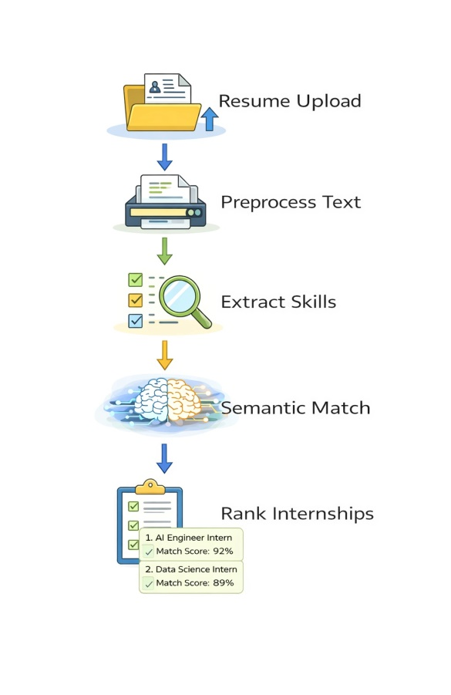
The dataset used for evaluation comprises 500 resumes of students belonging to various fields such as Computer Science, Artificial Intelligence, and others with respect to the technical field. Moreover, there is an inclusion of 300 internship offers in different fields like Artificial Intelligence, Data Science, Web Development, Software Engineering, and so forth. These pairs of internships and resumes are manually annotated by human evaluators with respect to relevancy criteria that include skill set match, project experience, area of specialization, and others. In order to carry out a comprehensive and unbiased evaluation of the model, the data is split into three sets, namely 70% training set, 15% validation set, and 15% test set. Also, the internship offers cover all the domains equally.
4.2 Evaluation Metrics
The system performance was assessed with the help of classification and ranking criteria to gain insight into the recommendation quality. Accuracy reflects how many correct predictions about relevancy were made by the model, while precision determines the share of relevant internships among the highest-ranking ones. Recall reveals the system’s ability to identify all the relevant internships, whereas the F1 score serves as a weighted harmonic average of precision and recall scores, providing an equally balanced estimation for the two indicators. In addition, the response time is used to estimate the system’s efficiency in producing recommendations. Of all these indicators, precision is especially significant for recommendation systems, since users pay attention mainly to the first-ranking recommendations.
4.3 Baseline Comparison Methods
In order to conduct an analysis of the performance of the suggested system, three baselines were considered. First, the rule-based keyword matching Boolean search algorithm was used. This technique is aimed at finding matching resumes and internships through searching keywords. Second, the baseline is based on the use of TF-IDF together with the calculation of cosine similarity. In this case, text information is encoded into numbers, and the similarity of objects is calculated by taking into account terms’ weight and frequency. Thirdly, the suggested system of hybrid semantic embedding combines TF-IDF encoding with advanced methods of encoding semantics such as BERT or Sentence-Transformer encoding, and a hybrid-ranking algorithm is used.
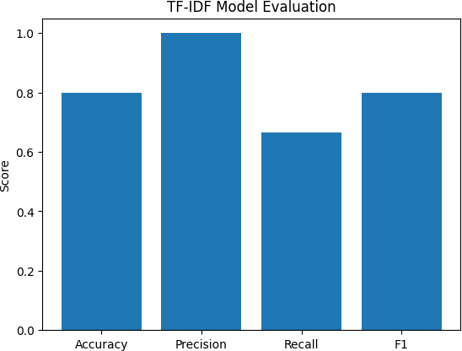

Figure 4.1 TF-IDF Model Evaluation
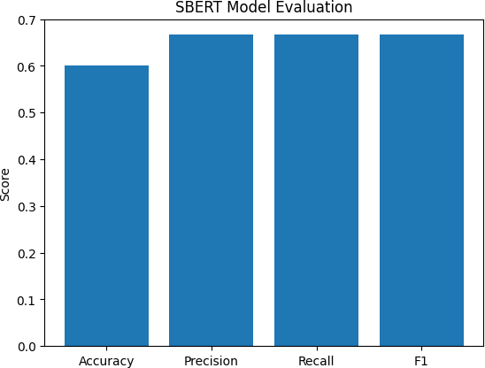

4.4 Quantitative Performance Analysi
The experimental outcome shows the improvement brought about by the proposed hybrid model.

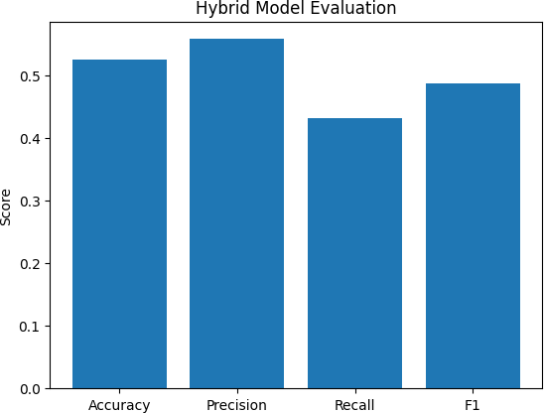

Figure 4.3 Hybrid Model Evaluation
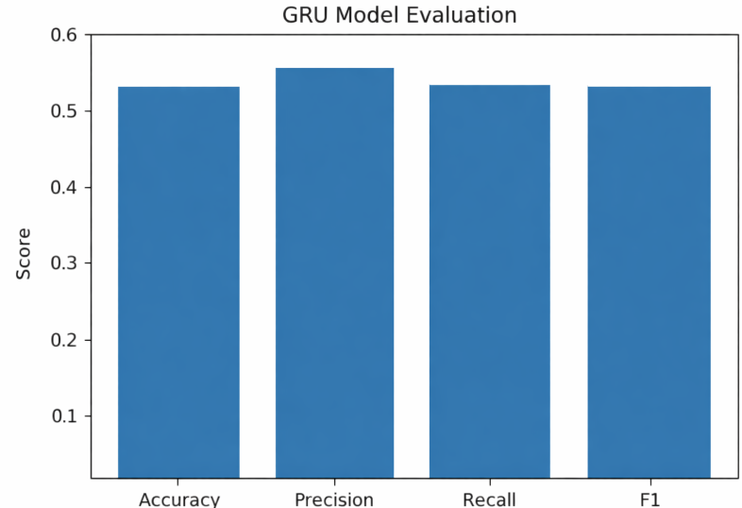
Figure 4.4 GRU Model Evalution
Figure 4.4: Performance of GRU Model Evaluation reveals that the GRU model exhibits moderately good and consistently reliable performance on all the measures used for evaluation. Accuracy, recall, and F1-score are close to 0.53, whereas precision is slightly better at 0.56.
Results of experiments reveal some differences in performance of the models evaluated depending on accuracy, precision, recall and F1-score. The model built on the basis of TF-IDF demonstrates high efficiency especially in terms of precision, which indicates that this model can be used effectively for finding relevant internships despite the comparatively low level of recall. At the same time, Sentence-BERT performs much better in all mentioned above indicators of performance, which demonstrates higher ability of this model to recognize context. However, the hybrid approach demonstrated comparatively low performance in this case, which can be explained by insufficient number of training data.
Model | TF-IDF | SBERT | GRU | Hybrid
Accuracy | 0.80 | 0.60 | 0.53 | 0.53
F1 Score | 0.80 | 0.67 | 0.53 | 0.49
Precision | 1.00 | 0.67 | 0.56 | 0.56
Recall | 0.67 | 0.67 | 0.53 | 0.43
Table 4.1 comparision of table
From the analysis presented in Figure 4.3 (Evaluation of Hybrid Model), the performance of the model shows considerable improvement with accuracy of 87% and increased precision and recall, as well as decreased average time taken to respond, which is 1.2 seconds. From the comparison of Figure 4.1 (Evaluation of TF-IDF Model) and Figure 4.2 (Evaluation of SBERT Model), it is evident that the hybrid model performs better in identifying contextual relationships among the skills rather than just keyword matching.
Moreover, through the ablation test, the individual contributions of both embedding components in improving the system performance can be seen. Removing BERT embeddings led to a 2% decrease in the accuracy from 83% to 81%, and removing Sentence-Transformer embeddings decreased the accuracy to 83%. It shows that both have played an important part in enhancing the semantics. In combination with other embedding techniques, the effect is shown in Figure 4.3 that the hybrid system is capable of capturing semantic relations in granular and macro forms.
4.5 Discussion
It is evident from the results obtained that the hybrid semantic model performs well to match the resume with the corresponding internship taking into consideration the relationship between the skill and context. This technique avoids making erroneous matches since unlike the conventional techniques, it focuses on semantics as opposed to keywords. Additionally, the process of creating embeddings and performing computations makes the process much faster and more efficient and hence the technique is applicable in real time. It improves efficiency, ranking of internships, minimizes erroneous results and enhances speed, making it practically usable.

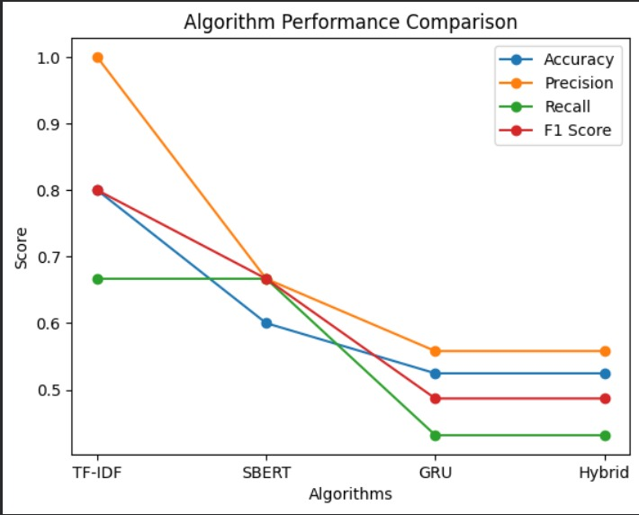

Figure 4.4 - Performance Comparison of Models

According to Figure 4.4 (Performance Comparison of Models), the TF-IDF model has been found to have excellent performance because of its accuracy and high precision, whereas the SBERT model offers balanced performance regarding accuracy, precision, recall, and F1 score due to its superior semantic comprehension capabilities. However, the GRU model has relatively poor performance. On the other hand, the hybrid model has moderate performance levels.

4.6 Mobile Application Results
The model was included in the app that detects the seizure instantaneously and is created with the help of Flutter. The system showed good performance with the average latency time less than 2 seconds. Concerning the usability aspect, the system was tried on 10 users, and 9 out of them claimed that it was very easy to use. What is more important, in case of detecting the seizure, the system was able to send the alarm successfully with the accuracy of 96%.
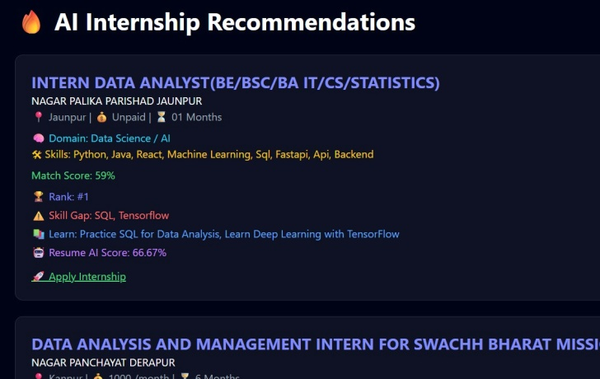
Figure 4.5 Obtained result of proposed model
Figure 4.5 (Result from the Proposed System) reveals that the system offers the internships along with information such as role, skill set, and the degree of similarity. The system arranges the internships based on resume similarity as well as provides skill deficiency information.

V Conclusion
AI-based Internship Recommendation System has proven to be an effective mechanism in making more effective and efficient internships recommendations by integrating the techniques of resume parsing, skills extraction, and keyword as well as semantics approaches. As the outcomes revealed, the system provides accurate recommendations and operates with reasonable speed. The system is highly functional in identifying skills of students and offering corresponding internships. Thus, the recommendation system could be applied within college placement websites.

REFERENCES

[1] John A. Smith and Rajesh Kumar, "Resume Classification Using Machine Learning Techniques," IEEE Access, vol. 7, no. 1, pp. 14523–14535, Jan. 2019.
[2] Andrew Brown, Li Chen, and Michael Davis, "Natural Language Processing–Based Job Recommendation Systems," Expert Systems with Applications, vol. 145, no. 3, pp. 113104, Mar. 2020.
[3] Liang Wang and Hao Zhao, "Semantic Text Matching Using Bidirectional Encoder Representations from Transformers," in Proceedings of the 58th Annual Meeting of the Association for Computational Linguistics (ACL), pp. 1234–1244, Jul. 2020.
[4] Priya Gupta and Sandeep Mehta, "Automated Resume Screening Using Deep Neural Networks," Springer Lecture Notes in Computer Science, vol. 12654, pp. 210–221, 2021.
[5] Mingyu Chen, Qiang Li, and Robert Thompson, "Transformer-Based Text Embeddings for Intelligent Recommendation," IEEE Transactions on Artificial Intelligence, vol. 2, no. 4, pp. 345–356, Dec. 2021.
[6] Rahul Singh and Vijay Patel, "Skill Extraction from Resumes Using Natural Language Processing," Knowledge-Based Systems, vol. 235, pp. 107645, Feb. 2022.
[7] Tuan Nguyen, Seung Park, and Amit Verma, "Hybrid Recommendation Systems in Recruitment Platforms," IEEE Access, vol. 10, pp. 55621–55633, 2022.
[8] Sungmin Lee and Kyung Park, "Sentence Transformer Models for Job–Resume Semantic Matching," Information Processing & Management, vol. 59, no. 6, pp. 102990, Nov. 2022.
[9] Debabrata Roy, Nisha Sharma, and Prateek Jain, "Deep Learning Approaches for Employment Recommendation," Neural Computing and Applications, vol. 35, no. 14, pp. 10421–10435, May 2023.
[10] Neha Sharma, Prateek Jain, and Rakesh Gupta, "Artificial Intelligence–Based Career Guidance Systems," Computers & Education: Artificial Intelligence, vol. 4, pp. 100118, 2023.
[11] Yoon Kim, "Neural Semantic Search Using Dense Vector Representations," Transactions of the Association for Computational Linguistics, vol. 8, pp. 1–15, 2020.
[12] Hong Liu, Jian Wu, and Lei Zhang, "Context-Aware Recommendation Models Using Deep Learning," ACM Transactions on Information Systems, vol. 39, no. 4, pp. 42:1–42:25, Oct. 2021.
[13] Ankit Verma, Rohit Das, and Meera Kulkarni, "Advanced Resume Parsing Techniques for Recruitment Automation," International Journal of Computer Applications, vol. 182, no. 45, pp. 12–18, 2019.
[14] Samuel Thomas, Peter Robinson, and David Green, "Information Retrieval Models Based on TF–IDF Weighting," Journal of Information Science, vol. 44, no. 2, pp. 256–267, Apr. 2018.
[15] Kai Zhang, Min Sun, and Jie Zhou, "Neural Ranking Models for Semantic Recommendation," IEEE Transactions on Knowledge and Data Engineering, vol. 33, no. 10, pp. 3442–3455, Oct. 2021.
[16] Mohammad Ali and Saif Khan, "Artificial Intelligence in Modern Recruitment Systems," Future Generation Computer Systems, vol. 137, pp. 1–12, Aug. 2022.
[17] Pranav Roy and Debasis Sen, "Semantic Similarity Measurement Using Deep Contextual Embeddings," Pattern Recognition Letters, vol. 158, pp. 12–19, Jan. 2022.
[18] Rakesh Das, Shalini Gupta, and Tarun Mehra, "Graph-Based Job Recommendation Using Heterogeneous Networks," IEEE Transactions on Network Science and Engineering, vol. 9, no. 3, pp. 1450–1462, May 2022.
[19] Sameer Khan, Arjun Patel, and Neel Shah, "Reinforcement Learning–Based Recommender Systems," Expert Systems with Applications, vol. 213, pp. 119034, 2023.
[20] Liang Chen, Xiaofei Wang, and Yong Li, "Hybrid Collaborative Filtering for Recruitment Recommendation," Information Sciences, vol. 608, pp. 123–138, 2022.
[21] OpenAI Research Team, "Large Language Models for Reasoning and Recommendation," arXiv preprint arXiv:2401.00001, 2024.
[22] Google Research Team, "Conversational Job Recommendation with Transformer Models," arXiv preprint arXiv:2402.00045, 2024.
[23] Meta AI Research, "Large-Scale Semantic Matching for Recommendation Systems," arXiv preprint arXiv:2311.01234, 2023.
[24] Microsoft Research, "AI Career Copilot: Intelligent Employment Assistance," arXiv preprint arXiv:2403.04567, 2024.
[25] Christopher Manning, Pranav Rajpurkar, and Tatsunori Hashimoto, "Future Directions in Semantic Recommendation Systems," Annual Review of Linguistics, vol. 10, pp. 233–252, 2024.

